Capital Alliance Finance
Level 5, Millennium House,
46/58 Navam Mawatha, Colombo 02,
Sri Lanka

Finsoft Solution
Proposed Financial Suite

Prepared For: Capital Alliance

Prepared By: Modular4

Description

Finsoft Solution is a comprehensive, user-friendly package consisting of the following components:
Lending – Leasing, Hire Purchase, Loan, Pawning
Borrowing – Fixed Deposit
Investment - RealEstate
General Ledger
This has been designed for ease-of-use, being menu-driven with consistent structures across all of the integrated applications. The database provides shared access to the information while ensuring complete integrity of the data.
Finsoft Solution provides many convenient reporting features, tailored to the roles of your decision. Also it is an application that optimizes the processes of exchanging documents between enterprises and managing documents within an organization by capturing and reading electronic copies – and eliminating the need for manual data entry.

Proposal Number: M4POP00002
Table of Contents

Project Purpose and Business Problem 3
Our Solution 5
Implementation Plan 8
Resource Requirements 10
Financial Estimates 12
About Modular4 13

Project Purpose and Business Problem
Finance software should provide users with an online environment within which they can maintain Customer records, Facility details, Referential documents, with minimum data redundancy & greater security. And improve employee performance and productivity by integrating business processes and data across the organization
Also it should provide the reports, graphs as per the state regulation and market trends.
Finally it should help with MIS reporting for better decision making.

Briefing on the problems identified in the existing system
Maintaining Client & Facility Information
There is a difficulty in identifying customers as there are no mandatory fields specified at Customer Entry. Also Vehicle information stored is insufficient, as its only Registration Numbers is captured. Due to exceeding data limits the Guarantor records created at all.

Providing Lending schedules
Due to the existing system constrains all schedules are still created following the Sum of the digits method, where the locally financially accepted method is being the Reducing Balance. Also due to the straight forward scheduling cannot cater any customized schedules such as step-down, step-up, balloon installment etc…

Fixed Deposit Renewals
Current system does not support auto renewals also it does not cater auto generating the Renewal Notices. At the moment renewal is done manually by closing the existing & creating as a new facility.

Warrant Processing
There is no flexibility in interest payment frequency while processing the warrant, where it is always done as Monthly. Also the printed warrant is manually maintained in spreadsheets where it causes process inefficiency & data to be error prone.

Reports Adhering to state regulatory mandates
As the existing system is not catering the creation of the CRIB compliance reports, uses a third party system to create those. Which adds data duplication as this system is not integrated to the main.
Also the system does not cater generating the Central Bank reports in proper format.

Finally the system lacks the following new trends / practices in the business field
- Automated GL entries; for example at Rental Debiting, Deposit Activation
- Proper Bank Reconciliation Process
- Comprehensive Petty Cash module

Our Solution

Finsoft Solution offers the chance to capture of data easily and accurately, facilitate processes, and generate data that is easily accessed and intuitive. It saves time and effort not having to duplicate the posting of transactions in both products. Also enables you to master the data needed to make fast, sound decisions while conducting business.
Finsoft Solution supports capture of data easily and accurately, facilitates processes, and generate data that is easily accessed and intuitive. The robustness of the product protects the business from internal and external fraudulent activity. Finsoft Solution simplifies the adherence to regulatory mandates and results in significant savings and provides protection against litigation.

Benefits of using our solution
Common Client Concept
Finsoft Solution maintains Customers, Guarantors if facilities and the Officers of the system in a method where each can play either role at any given time, which reduces data duplication. And the National Identity Card Number is mandatory in the system & it is validated as per the Central Bank regulations.

Comprehensive Security Module
A common security module is maintained through out the system, where each facilities security is recorded with proper integrity. Security types are customized and can be created & modified as your requirement.

Trial Calculation Feature
Finsoft Solutions Trial Calculation is implemented with a best practices and trends In the market.
For example it supports following repayment methods:
Equal installment, Step-Up, Step-Down, Balloon Installment

Enhanced Rental frequencies
With the Finsoft Solution you can have more rental frequencies than the usual monthly. For example; Weekly, By Annually, Annually, Quarterly, etc…

Appraisal Module
With the Finsoft Solution you can upload & store the referential documents, which supports further to analyze the customer exposure.

Integrated General Ledger Module
Due to the integrated GL module the system supports creating facility wise automated journal entries at certain business functions.
For example: Facility Closure, Activation, Rescheduling, Receipting, etc…

Automated Renewal & Warrant Processing
Finsoft Solution automated Day-End Process is updating the related facilities with Rental Generation, Renewal Notices, Warrant Processing, Penalty or Default Charges, Reminder Generation etc…

Bank reconciliation
Finsoft solution has a powerful matching algorithm to remove the difficulty of performing reconciliations. It is a paperless bank reconciliation procedure that is designed to minimize the number of bank statements that must be reconciled by hand each month.

Petty Cash Module
Finsoft Solution Petty Cash Module is custom designed to allow users to enter, review, and edit petty cash transactions, including replenishing petty cash funds. It is a faster and accurate way of generating and confirming your Petty Cash Vouchers

Automated CRIB & Central Bank Report Processing
Finsoft Solution automatically generates the files required by the Credit Information Bureau of Sri Lanka (CRIB) during the Month-End Processes, with no manual interference. It also supports the reports required by the Central Bank of Sri Lanka.

Information Centre
Finsoft Solution has an inbuilt report module with MIS reports, supporting better decision making, which can be customized as per user requirements
Some of the inbuilt reports are:
Ledger Card – Daily Transactions for a given facility
Image Viewer – Viewing Facility or Customer related images and relevant documents
Officer Diary – Users (Marketing / Recovery Officers) to maintain their Customer Visits
Contract Inquiry – History & Online Status for a given Contract

To-Do List
Finsoft Solution notifies the list of things to be done by a User at the system login.
For example;
Cashiers – Post Dated Cheques
Manager – Contract Approvals
Marketing Officers – Appointments list for the day

Assumption and Constraints
Current facilities using the Sum of the digits to recognize interest & capital will be maintained as per the existing schedule until closing the deal.
New facilities created through the new proposed solution will be using the Reducing balance Method.

Implementation Plan

Trial Run
As per initially discussed there will be a trial run for two weeks. We will provide a sample data & reports to be used during the trial period.

Data transfer Migration
Based on the study of the existing system one of the following methods can be used to transfer data from the old existing system to the new proposed solution
- Converting the clipper DBF files in to the New System
  - Meta data can be retrieving from the existing system; still certain amount of data will have to be manually entered.
- Data entered by users to the spreadsheets formats provided by us
- Providing an empty DB, where users will have to manually enter old data through

High Level Project Plan
Data Migration and Meta data keying 30 Days
Fine Tuning and Implementing All 6 modules
(Leasing, Hire Purchase, Loan, Fixed Deposit,
Pawning, General Ledger) 150 Days

Software Agreement
The Software Agreement to be signed with “Modular4 Solutions (Pvt) Ltd.”

Software Warranty
This software solution carries a warranty period of One (01) Year from the date of User acceptance test (UAT).

Software Maintenance
Maintenance services shall be provided under a maintenance agreement to be signed after the warranty period expires. The standard annual maintenance charges would be fifteen percent (15%) on the product price plus the subsequent cost of modifications.

Software Maintenance
Upfront 100% maintenance fees for a period of one year at the signing of the maintenance contract.
During such annual maintenance MODULAR4 shall rectify all software related faults, defects and malfunctions free of charge.

Additional Software Modifications
All additional software modification charges will be quoted after a detailed system study. The development of the modifications would begin once a written confirmation is given by the client.

Modification Charges
50% - on confirmation of the quotation
50% - on implementation of the modifications

Updates/New Modules
Customers under maintenance service agreement are entitled to free Application Updates within the same version, database, operating system, and application language (subject to application customizations done at the client’s site) of the modules purchased.
Other additional/new modules/new version upgrades would be available at a very special discounted price to your company.

Purchase Order & the Payments
Purchase Order and the payments to be issued to “Modular4 Solutions (Pvt) Ltd.”

Resource Requirements

Server Configuration

Feature Description
Processor | Intel® Xeon® 3.0 Core GHz (320 GB SATA model)
Memory | 4 GB (4 x 1 GB) or more
Network Controller | Embedded NC105i PCIe Gigabit Ethernet Server Adapter
Expansion Slots | Full-height, half-length 32bit/33MHz PCI at 3.3V slot  Full-height, half-length PCIe x1 slot (x8 connector)  Full-height, full-length PCIe x1 slot (x8 connector)  Full-height, full-length PCIe x8 slot (occupied by Smart Array E200/128MB controller on 1 TB SATA, 2 TB SATA, And 584 GB SAS models)  (1) Lights-out 100c option slot
Management | Microsoft Management Console (MMC)-based user interface  Remote system management via Remote Desktop or Telnet (Optional) HP Lights-Out 100c Remote Management Card
Operating System | Microsoft Windows Server 2003 Release 2, Workgroup x32 Edition (320 GB SATA model), Raid 5
Hard Disk Capacity | 1TB Or More
Form Factor | Micro ATX Tower

Client PC Features
Feature | Description
Processor | Core i5 Intel Pentium 2.0 GHz or Higher
Memory | 2 GB or more

System Architecture
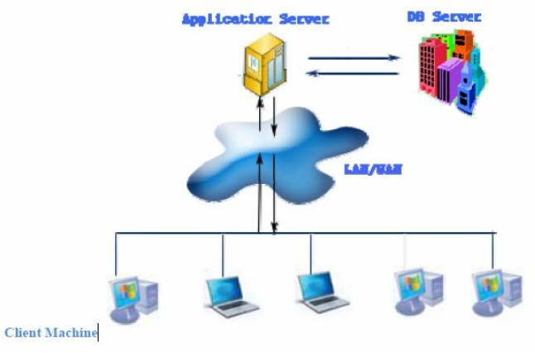
System Performance

Feature Description
Number of Contract 30,000
Number of Branch 15
Number of Users (Concurrent) 100
Network Band Width 100MBps
Facility Inquiry Speed 1 per second

FinSoft Development Architecture
Oracle 10g Data Base
Microsoft Visual Studio 2005 Development Tool
Crystal Report Reporting Framework






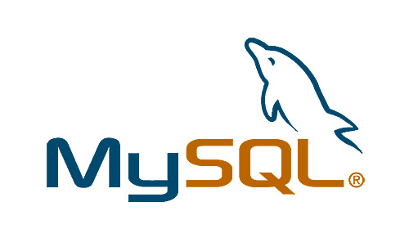

Financial Estimates

Pricing Summary

Cost of the Leasing Management Software Module | 1,500,000.00
Cost of the HP- Management Software Module | 750,000.00
Cost of the Loan - Management Software Module | 750,000.00
Cost of the Deposit Management Software Module | 1,000,000.00
Cost of the Pawn Management Software Module | 700,000.00
Cost of the General Ledger Software Module | 1,100,000.00
Total cost of software solution | 5,800,000.00

Note:
** MODULAR4 will sell the source code to the client five (5) times of the Software value on unlimited user license, if client needs.
** Unlimited user license will be provided for each module.

Currency of Offer
All prices are in Sri Lankan Rupees.

Proposal Validity
This proposal is valid for a period of one (01) month.

Payment Terms & Other Charges
Application System Charges
Option I
50% - on Acceptance of Proposal
50% - on Live Run

Option II
50% - on Acceptance of Proposal (Rs. 2,900,000.00)
50% - Rental Basis (Equally Divided in to 12Months – Rs. 2,900,000.00)

1st Month | 241,666.67
2nd Month | 241,666.67
3rd Month | 241,666.67
4th Month | 241,666.67
5th Month | 241,666.67
6th Month | 241,666.67
7th Month | 241,666.67
8th Month | 241,666.67
9th Month | 241,666.67
10th Month | 241,666.67
11th Month | 241,666.67
12th Month | 241,666.67

Training
User training will be done at site during implementation.
About Modular4

Modular4 has delivered cost effective and high-quality software solutions for a wide range of industries and domains. We work together to deliver the ultimate in customer satisfaction while also helping each business or company achieves their unique needs.
Our competence and experience ensures that we deliver excellent services and products to our customers.
At Modular4 we are proud of our high quality standards. These standards allow us to provide our customers with reliable software applications, regardless of complexity.

Contact Us
Dumindu Wijesekara Mahinda Jayakody
0773435429 072317666 / 0716825707
dumindu@modular4.com mahinda@modular4.com
Web Site : www.modular4.com

Our Clients
Client | User reference | Solution Provided
People’s Merchant Business PLC | Anuranga Indrajith  Manager IT | “Pawn – Brokering” Software Solution
Citizen Development Bank | Mr. Imdaad Nagiub  Senior Manager IT | “Pawn – Brokering” Software Solution
MBSL Savings Bank | Mr. Dushmantha Weerathunga  Manager IT | “Pawn – Brokering” Software Solution
Lake House Printers & Publishers | Mr. Rasika Karandawa | Online Bank Cheque Book Ordering and Cheque Printing (MICR)  Cheque return Notice Printing with Lanka Clearance Process data
City Bank | Mr. Sumeda Karunarathne  Product Manager | Post Dated Cheque management Software
Ideal Property | Mr. Peter Jayalath  Owner | Real Estate management Software
K.G.S Spear Parts | Mr. Sajeewa Ekanayaka  Product Manager | Inventory Solution

Confidentiality
All material, prices and other information provided in this proposal and other supporting documents, annexure, CD-ROMs, diskettes etc. should not be disclosed to any 3rd party without written consent.

We hope this pricing proposal would meet your requirements. Should you need any further clarifications, please feel free to contact us.


Thank You,
Yours sincerely,

D. Janeendranath Wijesekera
Director Marketing
Modular4 Solutions

